Department of Internal Affairs
Customer Experience Report

Release date: 11 July 2012
Prepared by: Trent Mankelow
Version no: 1.0 - FINAL

Optimal Usability Limited
Level 2
126 Cuba Street
Wellington 6011
New Zealand

http://www.optimalusability.com

TABLE OF CONTENTS

EXECUTIVE SUMMARY 3
BACKGROUND AND PURPOSE 5
SUMMARY OF FINDINGS 10
APPENDIX 1. Participant profiles 30
APPENDIX 2. Discussion Guide 34
APPENDIX 3. Other findings 38

EXECUTIVE SUMMARY

In June 2012, the Department of Internal Affairs commissioned research to explore how New Zealanders access government information and services online.

We conducted four focus groups with 30 participants from across New Zealand who had a wide variety of backgrounds and ages, from 18- to 80-years-old.

The problems that participants described when interacting with government online fit broadly into five themes:
1. Participants were frustrated when they couldn’t find the information that they wanted (page 10)
2. Participants were annoyed by broken websites (page 11)
3. Participants were annoyed by time-consuming processes (page 11)
4. Participants were irritated when their query wasn’t answered (page 12)
5. Participants were frustrated when government websites failed to take into account the end-to-end experience (page 12)

These findings are consistent with other research including How New Zealanders access public services (2010), Kiwis Count (2009) and Drivers of Satisfaction for Online Public Services (2010).

To address these issues, we asked participants to consider agile cross-government websites based around customer segments and topics (such as seniors, housing, and transport). While some participants liked the idea of these ‘information hubs’, many were lukewarm towards the concept, possibly because the hubs were abstract.

We asked participants to help define the attributes of information hubs, and their top ten were as follows:
1. Have an effective search engine (page 19)
2. Provide easy-to-find offline contact information (page 19)
3. Be user-friendly (page 20)
4. Provide the ‘right’ level of security and privacy (page 20)
5. Provide relevant and useful crosslinks to other sites (page 21)
6. Be task-focussed with an intuitive flow (page 21)
7. Do the basics well (page 21)
8. Remember me (page 22)
9. Provide live online chat (page 22)
10. Be consistent (page 23)

These attributes are potentially a useful starting point to develop overarching design principles, like those at gov.uk or the BBC.

Participants weren’t particularly interested in a central listing of government consultations, although it should be noted that we did not specifically screen for participants who had previously participated in government consultations.

BACKGROUND AND PURPOSE

Purpose
To date, government online channels in New Zealand have been designed in a way that meets the needs of each government agency rather than the needs of the individual.
The Department of Internal Affairs (DIA) is planning to redevelop the newzealand.govt.nz website in order to provide all-of-government information online in a customer-centric, easy-to-use manner based on customer needs, not the structure of government.
To inform the redevelopment, the Department wanted to know “what users’ expectations are when it comes to accessing government information online, and what difficulties are they having. The goal is to discover what people want and ‘what’s broken’ in all-of-government online information delivery.”

They identified specific question areas to answer:
- Their service ‘stories’ during recent interactions with trying to find government information online.
- What improvement do they think could be implemented to enhance their online experience?
- What are their perceptions of an ‘across government portal’ or multiple ‘information hubs’ for government?
- What are their perceptions of a central listing of government consultations? Would they be interested in using it?

Methodology
Focus groups were chosen to answer these research objectives because they are well suited to the type of open-ended questions identified above, and allow us to uncover a large amount of information in a short amount of time. Their free-flowing nature means that they are a very effective method for exploring attitudes, beliefs and requirements from a diverse group of people.

Each of the two-hour focus groups had four main activities:

- Specific experiences of government websites (25-30 minutes). We started by asking participants for memorable stories of recent online interactions with government. We seeded this discussion by providing cards labelled with different types of government services, taken from the Kiwis Count survey.

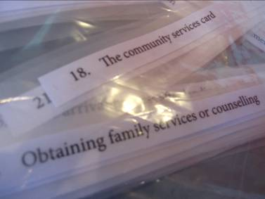
Figure 1. Packs of cards were used to remind participants of different government websites they have used

- Attributes of future government websites (20-30 minutes). We then asked participants what they thought of using ‘information hubs’ as a way of accessing government information and services. They then listed and prioritised the attributes of these hubs.

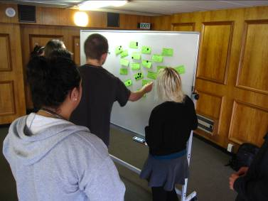
Figure 2. Dunedin participants voting on the attributes of an ideal information hub

- Drawing the future state (25-35 minutes). We then asked participants to reimagine the experience they described in Activity 1, and taking into account the attributes they described in Activity 2, to draw their ideal online experience. The drawing exercise was a way to get participants thinking creatively, and to further understand what improvements they’d like to see.

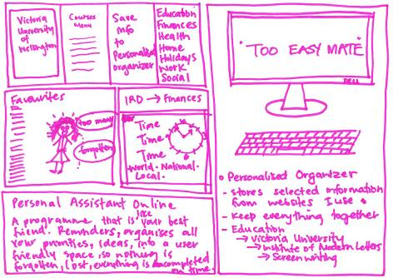
Figure 3. Drawing from a Palmerston North participant, showing her ‘online personal assistant’ concept

- Examining global ‘best practice’ (15-25 minutes). In order to ground the ‘blue sky’ nature of Activity 3, in the last exercise we asked participants to rate four existing websites using the System Usability Score (SUS). The SUS is a standardized questionnaire that gives a reliable and valid measure of usability using a simple, ten-item Likert scale. This exercise helped to understand participant preferences, while reducing the bias towards pages that looked more visually appealing. Participants rated the following four pages:

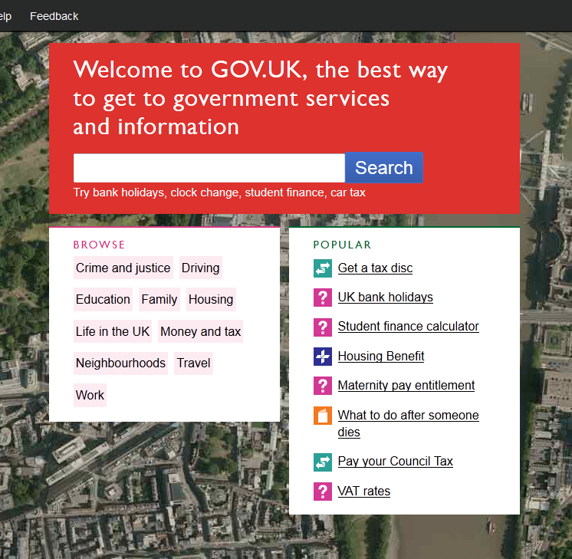  The gov.uk home page | 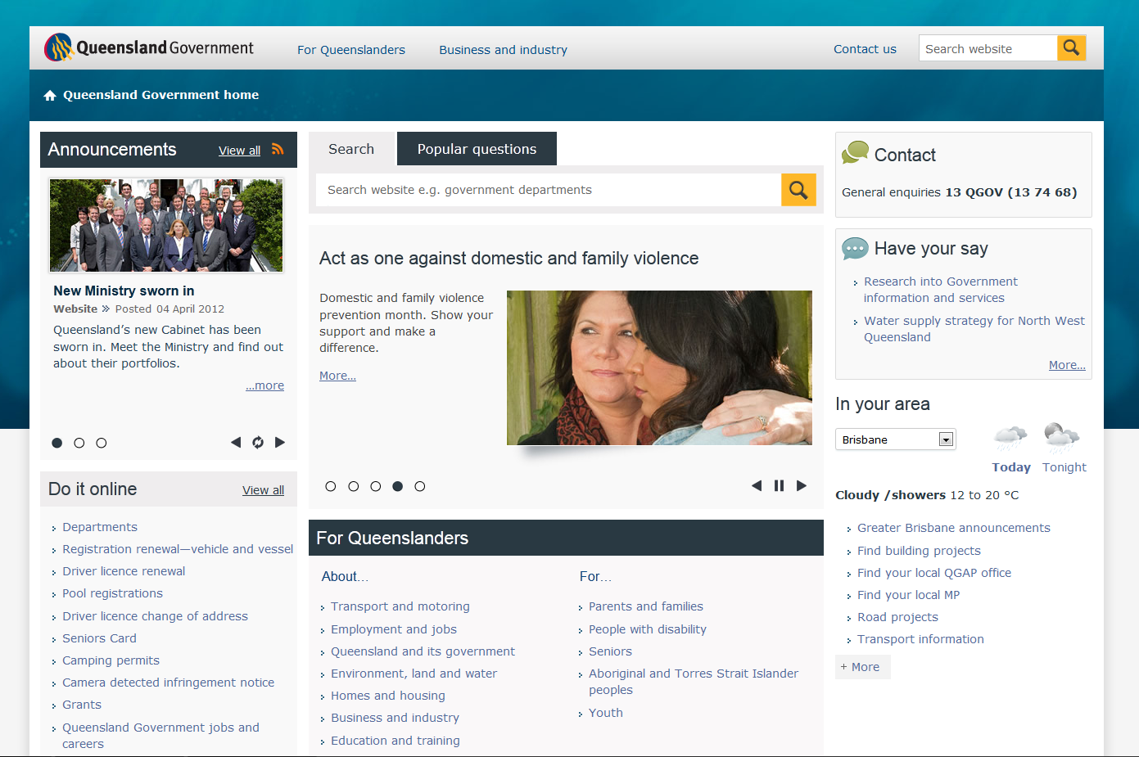  The qld.gov.au home page
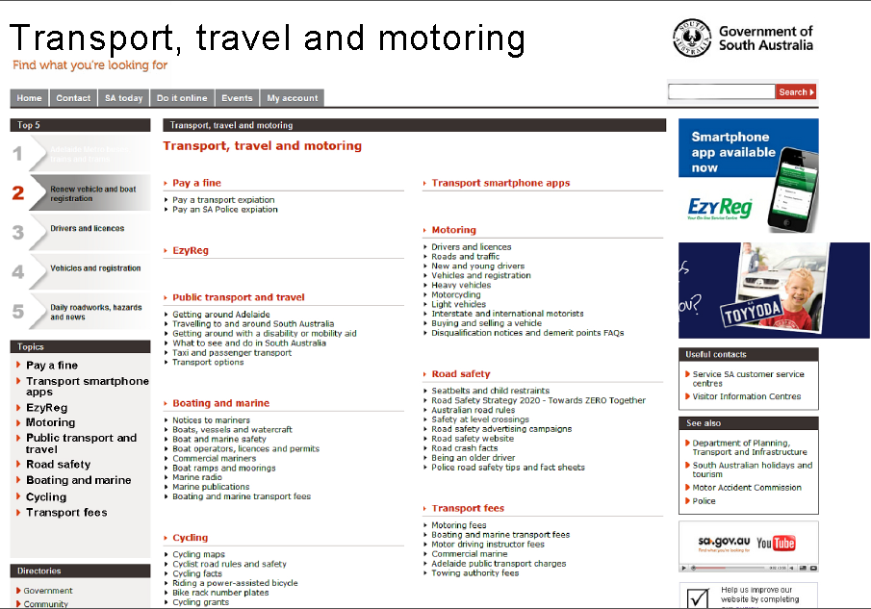  The South Australian Transport, travel and motoring landing page (edited slightly to look more like a home page) | 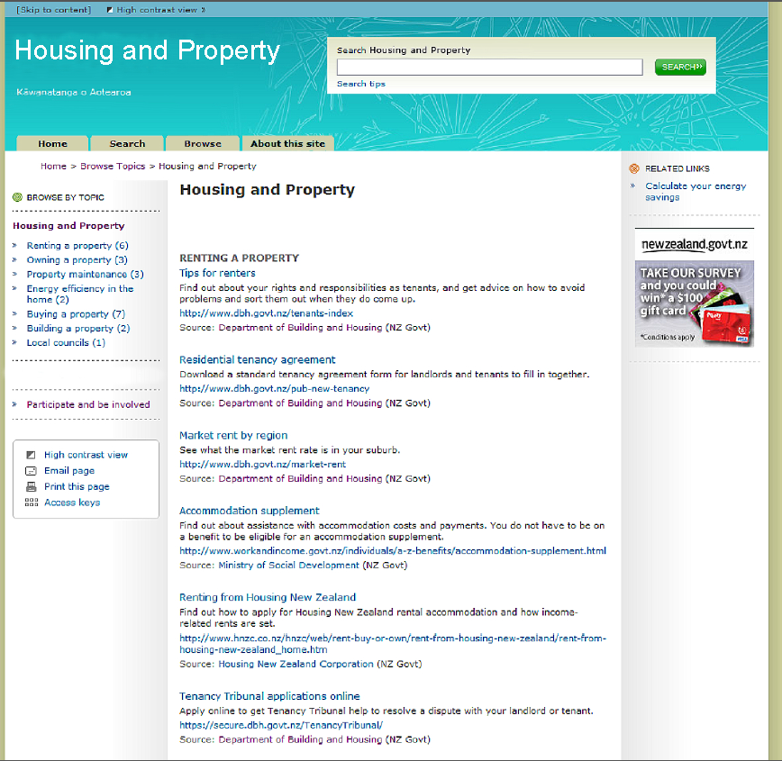  The newzealand.govt.nz Housing and property landing page (edited slightly to look more like a home page)

The full discussion guide for the focus groups is available in Appendix 2 on page 35.

Sample
We ran four two-hour focus groups in Auckland, Dunedin, Palmerston North and Porirua, and recruited each of the groups so that participants were roughly the same age. We had a wide range of household situations, occupations and ethnicities including people of NZ European / Pakeha, Asian, Pacific Island, Māori and Middle Eastern descent. Of the 30 participants we had more female (19 individuals) than male (11), and ages ranging from 18- to 80-years-old.

In this research we were particularly interested in the views of New Zealanders with more complex government needs, so we recruited a mix of super annuitants, short and long term beneficiaries and students. This led to a downwards skew for household income and we only had two participants whose household income was over $100,000 per annum.

The participants were familiar with online government services, and had each used between 3 – 15 different government websites in the last 12 months.

All participants were screened to ensure that they:
- Were a NZ citizen or resident
- Did not work for a government department, market research company, or for the media and did not live with someone who worked for a government department
- Had not participated in a market research study in the last 3 months.

More details about the participants are available in Appendix 1 on page 31.

SUMMARY OF FINDINGS

Participants perceptions of the current state of New Zealand e-government
One of the primary goals of this research was to understand how New Zealand citizens currently interact with government online, and in particular the things that were difficult and broken, in order to understand how improvements could be made. As a result, most of the comments and stories from our 30 participants were about their difficulties interacting with government online.

Of course, it’s not all bad news. Other research has shown that New Zealanders have high levels of satisfaction with online services provided by government. When we asked participants for their most memorable experiences with government online, approximately a third spoke of positive outcomes. Many of the participants spoke particularly highly of the vehicle licensing process.

The comments and stories from the participants can be categorised into five main themes.

1. Participants were frustrated when they couldn’t find the information that they wanted
Participants were frustrated when they didn’t know which specific website would be able to answer their question. Even once they got to the right site, many participants had stories of when they had struggled to find the “right answer”:
There is so much going back and forward, you can’t go straight to what you want. – Female, 68, Retired
I wanted to find about a court case for a man who had been stealing investments and I knew the person had been before the courts in the past few weeks. I accessed the courts website to try to find out if the proceedings had gone ahead and to find out the outcome. The website was hopeless. It was barely readable. I never found what I was looking for. It was very difficult in comparison to registering your car. It’s a dog. - Male, 71, part time Pastor
On the Inland Revenue site I couldn’t seem to get to where I wanted to go. Every time I entered a search it would take me somewhere I couldn’t understand and I couldn’t get the information I was looking for. It should have been quite simple - it didn’t make sense to me. – Female, 68, Part-time Cleaner

Participants also had a wide range of knowledge, experience, confidence and sophistication when it came to finding information online. Some participants confessed that they weren’t very good with Google, while others were quoting specific sections of the Immigration Act. Government websites need to balance the needs of sophisticated users alongside beginners.

Depending on what they are looking for, participants expected both general information and answers to specific questions:
I wonder why some of the government departments have a website. You go on there to ask a question and you can’t get the answer. You need to talk to a person on the end of the phone, as what they give you on the website isn’t what you need. They have standard questions answered, but it isn’t pertaining to what I want to look for. For example, when I’m building something tell me where I have to use treated timber and where I don’t. You often find generality not specifics. I don’t want general, I am looking for something specific. – Male, 79, Retired
Having general information is really important, but having specific information, personalised to you, is important too. – Female, 51, Teacher
I was sitting at work when there was a storm, and we could see on a roof nearby that there was some roofing iron stacked and it looked like it would start blowing away. It wasn’t important enough to call 111, so we wanted to look up the number of the local fire station. But we couldn’t find it. We found lots of good pages and educational stuff for kids, but we didn’t find the number. - Male, 47, Service Delivery Manager

2. Participants were annoyed by broken websites
Participants mentioned websites that were "broken" in various ways such as pages not loading correctly, links and buttons not working, and problems with logging in:
I logged in recently and I couldn’t remember my password. I was logging in at work so I was trying to do it really quickly. I clicked on ‘Forgot login ID’ and it said it would be emailed. And in the email it came up with prompt questions, which was funny, because if I forgot my password then why would I remember my prompt questions? And they said you have to phone them and reset it, which I didn’t have time to do. - Female, 40, Claims Technician Insurance
I couldn’t get in. I thought I’d know my password and login, but when it tried I wasn’t able to do it. You try to log in and it just doesn’t let you. I thought that I had used the right password and username because there was no message that it was incorrect…So I haven’t filed my tax return yet because it didn’t let me in. And when I tried to call the help desk, my cell phone battery ran out. - Male, 45, Unemployed

3. Participants were annoyed by time-consuming processes
Some online processes, especially more complex processes such as applying for a student loan, a job or a benefit, are considered to be unnecessarily time-consuming:
I spent a lot of time applying for a loan. - Female, 18, Student
For example, I applied for a job at Transpower. You have to be registered with them to do that. I found the process of actually applying with them to be very long-winded and anyone with a bad temper would just say ‘stuff it’. – Male, 45, Unemployed

This was further exacerbated when participants felt that the government should already have their information. Some participants were frustrated when reapplying for a passport or student loan, that they couldn’t just review the information on file and click a ‘nothing has changed’ button:
The painful thing was having to go through it again. Instead of saying ‘nothing has changed’ you have to say again - I have no children, no disabilities - all one-by-one. - Male, 19, Student

There was a general perception that government departments don’t talk to one another and don’t share information:
I find with all the government departments that they don’t seem to connect - one hand doesn’t know what the other hand is doing. There are no conversations between the different departments; they don’t seem to liaise with each other. – Female, 72, Retired
A friend of mine was on a benefit and then she started studying. But when she wanted a student allowance they said she still got income through WINZ. Sharing information, they’re not really good at that. Even if others have information on you, it’s not necessarily up-to-date. – Female, 22, Student

4. Participants were irritated when their query wasn’t answered
Participants were annoyed when they had to chase agencies to get an answer to their query:
I emailed IRD, but they never got back to me. - Male, 35, Dairy Farmer
I contacted them [WINZ] when I hadn’t heard anything for almost two months. I had no idea whether my application had been processed or not as I didn’t hear a word from them. I wouldn’t have got my Super if I hadn’t chased them up. - Female, 65, Retired

5. Participants were frustrated when government websites failed to take into account the end-to-end experience
According to How New Zealanders access public services (2010), “multi-channel access to services is the preferred approach for a wide range of New Zealanders”. However, it appears that many public sector websites fail take into account the cross-channel nature of citizen’s interactions – across channels, across time and across agencies:
I had to fill out these forms online, print them out, send them to Mum and she had to take them to the Australian government and confirm how much money she was earning. And when she sent it back to me, I couldn’t do anything else with it online; I actually had to go into StudyLink. - Female, 22, Student
When I first applied for my loan, I filled the form in, sent it off, they sent it back and I was supposed to highlight what was wrong. I did that and it came back the same. I was under time pressure so I was doing it via phone and email too. I got the form back three times, I did it online a couple of times and I rang them a few times. - Female, 19, Student

…Across channels
Online
Given that online channels have such high customer satisfaction, it is no surprise that many participants preferred to interact online:
It’s faster going through the internet. - Female, 56, Caregiver
It’s much better than ringing; you wait for ages with IRD. - Female, 36, Part-time Sensory Analyst
If you’re just another number, you might as well be a digital number. – Male, 47, Service Delivery Manager

However, some participants wanted to do everything online, and were frustrated when they had to use another channel to complete their transaction. Expectations are being set by the functionality on other non-government websites such as online banking:
You shouldn’t need phone calls - everything is already there. – Female, 68, Retired
Like Kiwibank and Sky, any bill, they let you opt out of getting your stuff by mail, and get it by email instead. – Female, 36, Sensory Analyst
I’m surprised they even still send letters; it’s so expensive and time-consuming! – Female, 40, Insurance
In an ideal world it’s all self-service. – Male, 47, Service Delivery Manager

Participants who didn’t own a printer were particularly frustrated by forms that required printing:
Ink is more expensive than petrol… So why print it out if they can email it to you? – Female, 32, At-home mother
The problem with the internet is that everyone thinks you have a printer attached to your computer. – Female, 65, Retired
I have been on [the DIA website] to apply for a new passport. They tried to get me to print it out and sign it, but I don’t have a printer. I had to get them to post it to me. – Female, 68, Retired

Phone
Even participants who generally preferred the online channel would call if they were stuck or were dealing with a more complex issue. Some participants liked to find out information online before calling:
I would not bother if it would not work once, I would just ring. - Female, 22, Student
For a lot of queries, I want to hear the response. I want to hear how they see the issue. - Female, 56, Caregiver
It’s quite good if you have some information before you make a phone call. – Male, 47, Service Delivery Manager

Some participants found it frustrating when government departments won't accept mobile calls on their 0800 numbers. For certain groups, this can be particularly problematic – for example, only two of the eight Dunedin students we spoke with had a landline where they lived:
As far as I remember, you have to call from a landline. I have a cell phone, so I had to go into the branch. – Female, 21, Student
I think it’s quite common for students to have no landline. - Female, 19, Student

Surprisingly little mention was made of using mobiles to access online services, possibly because few of our participants owned a smartphone. For example, only two of the eight Dunedin students and two of the seven Porirua participants owned a smart phone:
Mine has the capability but it’s really expensive, getting the plan. - Male, 19, Student

However, participants anticipated that they might use their mobile to access government information and services in the future:
In 5 years’ time mobile may be the main thing you are using government websites through. – Female, 40, Insurance
In the future it may be common place. – Male, 47, Service Delivery Manager

…Across time
Participants don’t always have time finish complex processes in a single sitting:
I was the same with the student loan. I had tons of problems, I got something wrong. I had to resend the information 7 times. I got it, and highlighted it and sent it back and I just kept getting the same form back every time. You highlight if something is wrong and send it back. Then I got it back, no changes, 7 times. That was fairly irritating. - Male, 19, Student
Sometimes you run out of time to sit on the computer and you need to take your phone. – Female, 65, Retired
I didn’t go through it in one sitting. - Female, 18, Student

…And across agencies
Many participants could recall having to visit multiple government websites to find the answers they were seeking or to complete their application:
I was a bit late paying my speeding fines. I went through to the police website but they had already sent it to court. I couldn’t see that there so I paid my fine, but a day or two later they send me a letter saying ‘You never paid us!’ I rang the police…they probably would have come and took my TV if I wouldn’t have rung them. – Male, 28, Contract Milker
Connecting IRD with StudyLink [would be good], so many students have to do that. There should be an explanation about how to get your IRD number [on the StudyLink website]. – Male, 19, Student
IRD should know everybody’s tax as they know everybody’s income. But at the moment I have to go through 3 different agencies to get my income. It’s WINZ, plus IRD, plus my job. And all of them are tax-related, so IRD should have all the info. – Female, 36, Sensory Analyst

Participants had a lukewarm reaction to the ‘information hub’ concept
Rethink Online introduced the need for online information and services to be organised around topics and audiences rather than agencies. We presented this idea to participants as ‘information hubs’ and while in general participants didn’t have any major aversion to the franchise model, neither were they particularly impressed or excited. While some participants thought it was a good idea…:
It would stop all of this back and forward, it would make it easier. I think it would help seniors, as there are lots of seniors are going on the net. I think it will encourage them. – Female, 68, Retired
If you could go to one website you could get all the bits and pieces you need. You normally have to cross all over. - Female, 56, Caregiver
Hell yes! That’s much better than trying to sort out the different departments. - Female, 56, Caregiver
I’d like to just start from one place because then I don’t have to remember what kind of government department it is, or whether it’s .org.nz. Then you maybe just look for income tax instead. – Male, 47, Service Delivery Manager
I think that’s a good idea; there would not be so much paraphernalia to go through. It would be good for everything to be on one site and to be referred on to other sites if you need them. – Female, 72, Retired

…Others didn’t understand the problem the hubs would be solving, and questioned whether they were necessary. This ambivalence reflects overseas evidence that suggests that users do not care about being taken from site to site:
Is the government ineffective at the moment? – Male, 19, Student
But how hard is Google search? Getting to the right government websites was pretty easy, just on the websites [search] doesn’t work anymore. - Female, 19, Student

Our belief is that participants couldn’t visualise how the hubs might work, particularly as they had almost no familiarity with the existing newzealand.govt.nz or iGovt services. No one mentioned either of these sites without prompting, despite some participants describing them almost exactly:
I often get stuck with the password. So you should have the same one and it’s all interlinked. So if you change your password in one, it’s for the others too. And every time it got reset it would change on all the other government websites too. It’s just having the same login on all websites, it’s the same for everything. – Female, 40, Insurance
You should have them all in one website, instead of having to go through all the different department websites. – Female, 52, Sickness Beneficiary

Participants had some concerns about the information hubs, in particular:
- What information would be in the hubs? How would that information be categorised? How would the hubs deal with overlaps in information?
The government would have to figure out what should be in each ‘hub’. For example, there are so many different layers to what ‘housing’ means. Maybe you have one site that is NZ government and you have a thread that lets you link through the different layers and different sites. Then the website may sit under a particular Minster, like the Minister of Housing. – Male, 71, Part-time Pastor
The question is how they categorise it. - Female, 19, Student
As long as the info that overlaps is identical. – Male, 19, Student

- Will combining bad websites make them even worse?
I totally disagree! I think some government websites are really not user-friendly. If you combine a couple of dodgy ones together, it will be a nightmare! – Male, 39, Technical Sales Rep

- What will this mean for the security and privacy of information?
When you fill in a form you need to know who can see it! - Female, 19, Student
It would make it easier for you, but maybe you don’t want other departments to know [your details], like WINZ. – Female, 22, Student
My concern would be that you have all your info combined. If someone was accessing your profile with all that information, then that would be a huge issue! – Male, 19, Student

- How will smaller interest groups be treated?
Say if you’re in an environmental group, and you’re not a large part of a department, what kind of information would you have on the front page? Would you have the same amount of care and attention as the other department sections? – Female, 51, Teacher

Participants suggested variations on the hub theme, including role-based (e.g. drivers) and goal-based (e.g. a hub for paying fines) sites.

Top 10 attributes of government information hubs
We asked participants to suggest and then vote on the most important attributes of topic-based information hubs. Combining the results of all four groups lead us to the top ten attributes outlined below:

Overarching attribute  “The website should…” | Attributes from individual focus groups | Votes  (combined across all four groups)
1. Have an effective search engine | Search / Search engine as effective as Google /  Search / Search should be forgiving - if you forget a letter: 'Did you mean?' / Search hubs that take you to the right place / Support keyword search | 22
2. Provide easy-to-find offline contact information | Easy to get in touch with a human / Contact details for help desk / Has contact phone numbers - not 0800 as they are tedious / Answer the phone as well! / Name of people to contact if you can't find the info you’re looking for | 16
3. Be user-friendly | User-friendly / Not too wordy / Easy to read, font not too small / Respects people’s limited time / Quick - don't want to have to go through 20 steps / Easy for people with low technical skills | 16
4. Provide the 'right' level of security and privacy | Privacy/ID theft is protected / Privacy - security of information / Need to know who can see the info you give them / Security of your information / Right level of sharing between Government departments - balance between to too much & not too little | 15
5. Provide relevant and useful crosslinks to other sites | Good crosslinking of info from other sites/hubs / Link to one another / Good cross-links between hubs / Should include links to local government | 11
6. Be task-focussed with an intuitive flow | Well categorised - navigation is key / Well defined hubs / 4 - 5 major categories w auto-filtering | 9
7. Do the basics well | Always available 24/7 / Easy to remember URL / Up-to-date | 9
8. Remember me | Remember your information / Pre-populate the forms with your details / Save your info/process / Personalised to you, e.g. favourites list | 8
9. Provide live online chat | Online chat with live person | 6
10. Be consistent | One department won’t tell you something different from another one / Interaction between departments, talking to one another 'a one stop shop' / Consistent information | 6

1. Have an effective search engine
Participants’ number one requirement for the information hubs was an effective search engine, and by “effective” participants really meant “like Google”. The search engine should be powerful and forgiving of spelling mistakes and non-government language. The dominance of search is consistent with Australian research that suggests that 80% of users start their search with a government service with Google.
Google fascinates me how it can read my mind - so often it’s exactly what I want - but the government websites don’t seem to be the same. The search engines should be as effective as Google. – Male, 71, Part-time Pastor
You should be able to put in keywords and get straight to what you want. – Female, 68, Retired
Google is really good. If you’re not quite sure you can Google what the subject is and they will ask you ‘Did you mean?’ – Female, 52, Sickness Beneficiary

2. Provide easy-to-find offline contact information
As we saw above, participants often call when they get stuck or have complex needs that aren’t suited to an online channel, so having easy access to contact information was important:
When you can’t find some information on a website, I would like a name or number you can contact to get more information. – Male, 79, Retired
Having a contact number is important so you can confirm or verify the information is correct. – Female, 65, Retired
And I’d like to see an option where you can ring them as well, rather than emailing them. – Female, 21, Student

Participants appreciated choosing how they interact with government:
If it was me, I’d want the options presented: do I want call, online or appointment. Everybody prefers to do stuff in a different way, some prefer online, I prefer talking to someone. – Male, 19, Student
It should have an email, phone number and local branches, easily visible and clear so you know there are options other than doing it online. – Female, 22, Student

3. Be user-friendly
Participants thought government websites should be intuitive and easy to use:
It should be easy for anybody with any technical background. – Female, 52, Sickness Beneficiary
The ideal experience is about removing barriers and making it easy. – Female, 65, Retired

It was also important to provide quality, easy-to-read content:
You often come across phrases or words that you can’t understand. - Female, 19, Student
Simple, simple English. – Female, 37, Educator
Not too wordy, either. - Female, 56, Caregiver

4. Provide the ‘right’ level of security and privacy
Security and privacy concerns were brought up by every group, but individual attitudes ranged from complete distrust to complete comfort:
I want to be careful that other people can’t access my information. I want to know that future employers can’t find out information about me on the government websites, like if I have demerits or fines. – Male, 71, Part-time Pastor
I want security too, so that not everyone can access your information. – Female, 40, Insurance
With everything going online, security gets more and more important. – Male, 19, Student
All government departments are government departments, so there’s no reason why the one hand should not know what the other is doing. - Female, 37, Educator

Most participants wanted relevant information about themselves shared from site to site when it saved them time:
[The sites] should link, so they know the information you gave them before. – Female, 40, Insurance
The police and the courts should share their information…yes, that makes sense! – Female, 36, Sensory Analyst

5. Provide relevant and useful crosslinks to other sites
Participants felt that the fragmentation of information and services across agencies could be partly alleviated by timely and relevant cross linking between sites:
With some things you need to go different places. To pay a speeding ticket you may think ‘transport’ because that is cars, but paying fines is a police matter. They should link up and take you to where you want to go. – Female, 65, Retired
It has to overlap, if you are on a student site to begin with and you move back to housing, you should get back to the student part if you want to. – Male, 19, Student

6. Be task-focussed with an intuitive flow
It’s not enough for government sites to be easy to use, participants also want to them to be goal-oriented and to help them quickly achieve their tasks. Participants thought that an intuitive flow was an important way of achieving this:
They must respect people’s time. – Female, 68, Retired
Get what you want done. – Male, 28, Contract Milker
You’re not logged into a government website to play online games. You need to achieve you goal, the website needs to get the job done and it needs to be user-friendly. It has to be designed to get you to achieve what you want to do in the shortest time possible. – Male, 39, Technical Sales Rep

7. Do the basics well
Participants brought up a number of hygiene factors. The felt that well-designed government websites should:
- Be convenient and available 24/7
And available at all times. You don’t want to have that message ‘down for maintenance’. – Female, 52, Sickness Beneficiary

- Have readable fonts
Topics in bold, something easy to read, not a small font. – Female, 51, Administrator

- Load quickly
Must be quick, must load quickly. We all have our own limitations with the hardware we are using. – Male, 71, Part-time Pastor
That’s a given today anyway, quick to load with broadband. – Female, 52, Sickness Beneficiary

8. Remember me
All of the groups talked about the government remembering and reusing key information. They felt that pre-populating forms would help them complete their tasks quicker:
And I should not have to enter everything over and over, they already have the information, I should not have to enter that again. – Female, 40, Insurance
And wherever it can save something, it should remember the details that I need to put in. – Female, 27, Unemployed
It’s ridiculous that you have to do the exact same things when you renew the passport as you did when you got your very first passport. – Female, 36, Sensory Analyst

The concept of an all-of-government profile that would follow participants from site to site was popular (particularly amongst the students in Dunedin), although it did raise some concerns about privacy and security:
Perhaps if you do any government-related stuff, like applying for driver’s license, your profile could be automatically updated, that would save you a lot of time. If you have a profile on a student website and on a housing website, and you made changes on the one site it would be good if it updated all the others. – Male, 19, Student
You should have a generic profile about you, and there could be like a sub-questionnaire if you wanted to add something more. - Female, 19, Student
You could have your history [of interactions with ACC] come up too. - Female, 56, Caregiver

9. Provide live online chat
The Palmerston North group were very interested in the ability to be able to live chat with public sector agencies. The Palmerston North City Council has an ‘Online Chat’ feature and 7 of the 8 participants in the group had used some kind of live chat before. They saw it as a good middle ground between calling and browsing a website:
What they have on the Palmerston City council website is a live chat, you message them and they answer you straight away. – Female, 40, Insurance
There’s no waiting [on hold], no music. – Female, 37, Educator
And sometimes the person on the phone may not speak good English (although not often with the government). But actually you really understand it when you read. – Male, 39, Technical Sales Rep
What’s also really good is you can get a transcript. You have a person’s name and a record of what has been said. – Female, 40, Insurance
If you don’t find or understand something, you get someone on the online chat [and] they can just solve it right there. – Female, 40, Insurance

10. Be consistent
Participants valued consistency within and across agencies and channels:
[In an ideal world] one department wouldn’t tell you something different from another department. I have had the same department tell me two different things. A friend from Customs said something different to the man from the Customs department who rang me on the phone. – Male, 79, Retired

More themes are covered in Appendix 3 on page 40.

Participants had a lukewarm reaction to a central listing of government consultations
In general, participants were lukewarm about the idea of a central listing for government consultations. While some thought it was a good idea:
I would like that! – Female, 68, Retired
I think it’s a good idea. I like to have my say on what’s happening. – Female, 72, Retired

…Others were cynical about how much difference their input would make, especially given how frequently they receive automated replies from government websites:
I feel like when I write a comment that no one reads through them, there must be hundreds, it’s just in a pool. - Female, 19, Student
They [the government] don’t like to be told what to do; they like to tell you what to do. – Male, 79, Retired
I have never received an actual response from a government site, only automated stuff which makes me feel it just goes into a big pile. – Male, 19, Student

Some participants wondered how a central listing would work and who would run it:
Who would run it? – Male, 79, Retired
It has to be driven from somewhere; otherwise there would be millions of unrelated grievances coming in. – Male, 71, Part-time Pastor
I’d wonder how many people they’d need to have to read and answer all that. – Male, 19, Student

Some participants wondered how they would winnow the consultations to only those that they were interested in:
Maybe there would be too much stuff. I don’t care about recycling but I do care about student allowance. Maybe if there was something about student allowance and it was on a student website? - Male, 19, Student

It is worth noting that we did not specifically screen for participants who had previously participated in government consultations.

Participants preferred the South Australian landing page, but not by much
We showed participants four web pages from existing public sector websites from New Zealand, Australia and the United Kingdom. The pages were chosen to showcase a variety of different visual styles and approaches to the franchise model. We asked participants to rate each page on the extent to which they agreed with 10 statements:

- I think that I would like to use this website frequently.
- I think that the website is unnecessarily complex.
- I think the website is easy to use.
- I think that I would need help from a customer support person to be able to use this website.
- The various parts of this site fit together well.
- I think there is too much inconsistency in this website.
- I would imagine that most people would learn to use this website very quickly.
- The website looks very awkward to use.
- I feel very confident that I could use the website.
- I would need to learn a lot of things before I could get going with this website.

The results show that none of the pages were considered outstanding examples of e-government, and while the South Australian Transport page had the highest SUS score, there was no one page that was universally liked.

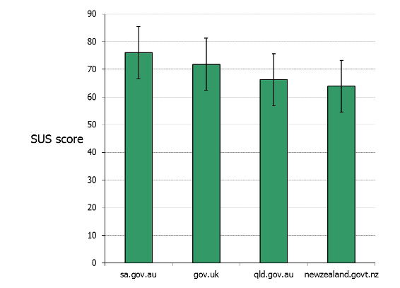

Page | Grade | SUS Score | Standard Deviation
- sa.gov.au –Transport, travel and motoring landing page | B | 76.0 | 19.6
- gov.uk home page | C+ | 71.8 | 23.2
- qld.gov.au home page | C | 66.2 | 19.3
- newzealand.govt.nz – Housing and property landing page | C | 63.9 | 20.4

- South Australian Transport, travel and motoring landing page
In general, participants thought the page guided the eye, had clear and relevant headings, and was easy to follow:
It is very clear, very easy to follow, good headings, everything you want. – Male, 71, Part-time Pastor
Easy to navigate and there’s information straight there. The boxes on the side had a link straight to customer services. - Female, 18, Student

Some participants complained that the ads made the page seem busy, and thought the font was too small:
With the ads it looks much busier. – Male, 19, Student

- Gov.uk home page
The gov.uk home page polarised the participants. Some loved the simplicity and visual interest:
I think it’s really easy. It’s just a search engine, and so long as it’s an effective engine, that’s all it needs to be. – Male, 19, Student
It’s got the main categories there just under the browse. – Female, 22, Student
It’s good that it’s got ‘popular’ too. – Female, 19, Student
It’s the prettiest and it’s the simplest. Straightforward and easy. – Female, 27, Unemployed

However, others thought the background was distracting and wondered whether the apparent simplicity just meant more work once they’d submitted a search query:
The pictures are distracting. It’s best to have something plain and non-distracting. You don’t need colour and personality if you’re searching. – Female, 68, Retired
It just looks dirty with the background. – Female, 21, Student
When I go to a website, I normally have a specific question in mind, and this may be too simple, too broad. - Female, 19, Student
You actually have to know exactly what kind of keywords you’re looking for. - Male, 19, Student
It would just matter how good the search engine was. If I typed in ‘student loan’ I need to be sure that the right things come up, not all documents they have on student loans, but an actual proper page. - Female, 18, Student
What I don’t like is that there’s no consistent navigation. I don’t know what would happen after I’ve searched something. – Female, 21, Student

- Queensland Government home page
Some participants liked the local feel to the page, and extra personality shown by the photos and colour:
It just seems easy to use, lots of blank space as well as text, not overwhelming and it’s using search too. – Female, 21, Student
This one has everything in it, it has colours and you can see what you have. – Female, 37, Educator
I thought that would be good for local government, because it’s about engagement and about community and it is topical. It’s got relevant things for your community, your local council. It has what nothing else has: cultural diversity! All these other websites don’t acknowledge that we’re multicultural as well. – Female, 51, Teacher
It’s got colour, too. – Female, 51, Administrator
I kind of like that you can pick your area, so you can see what’s happening in your area. – Female, 19, Student
I could make it my homepage! Everything you need to do, some local stuff, weather… – Male, 39, Technical Sales Rep
I love the weather. It’s the first thing I check in the morning. – Male, 35, Dairy Farmer

Others didn’t like the design, thought that the page had too much information, and considered the weather superfluous:
It’s so overwhelming, where do I start?! - Female, 18, Student
Lots of different areas. - Female, 19, Student
There’s too much white space. – Male, 47, Service Delivery Manager
The pictures are quite distracting. That space is taking up quarter of the page, could be put to better use. - Female, 18, Student
It says for Queenslanders, but there’s no option for non-Queenslanders, it cuts you out. – Male, 45, Unemployed

- New Zealand Government - Housing and property
The participants who liked this page talked about its perceived usefulness, relevance and straightforward content:
It doesn’t look nice, but if that website existed I would go on there for next year’s flatting and it would be super easy. It doesn’t look good, but it works really well. – Male, 19, Student
It looks easy to use and when you read the info, it looks like it really gives you something useful. – Female, 19, Student
I liked it, it has some clear headings. – Male, 47, Service Delivery Manager

Participants all agreed that the visual design of the page could be improved. They didn’t like the small font in particular:
The print is so small. - Female, 51, Administrator
It could do with a larger font or a facility to make it larger. – Male, 45, Unemployed
It’s not memorable. – Female, 32, At-home mother
I didn’t like it. It looks very busy. Why do you need the information and the web address there, you just need the bold heading. I just want it simple. - Male, 28, Contract Milker
I’ve been on that one and it seems like it shuts the door in your face. It’s certainly not something that the average person who’s looking for housing, with low income, can engage with. - Female, 56, Caregiver

Participants thought that some personality was OK on government websites
Reviewing the example sites often kicked off a discussion about how much personality was appropriate for government websites. Generally, participants thought that some personality and ‘colour’ was needed, so long as it didn’t distract from the task at hand and had broad appeal:
There should be themes of New Zealand in the background. – Male, 39, Technical Sales Rep
If they had a personality, it may be stereotypical. Who decides what kind of personality it would be? It could be that some people don’t like it then. – Male, 19, Student
Some people like to be more formal and some like to be more friendly. – Female, 19, Student
Often it’s so cold. That’s why I don’t like online, you just get finished off. - Female, 56, Caregiver
A little bit [of personality] can’t hurt, it can’t be too boring. – Male, 35, Dairy Farmer
Colour is quite distracting as well. – Female, 19, Student
Just a bit of colour. – Female, 27, Unemployed

APPENDIX 1. Participant profiles

Focus Group 1 - Auckland, 18 June 2012

Occupation | Age | Gender | Ethnicity | Household Income | Household Situation
Retired | 68 | F | Singaporean | Under $50K | Married - Children left home
Part Time Cleaner | 68 | F | NZ European | Under $50K | Single - Child at home
Retired | 65 | F | NZ European | Under $50K | Widow - Children left home
Retired | 80 | M | Indian | Under $50K | Widow - Lives with Daughter
Part Time Pastor (Semi Retired) | 71 | M | NZ European | Under $50K | Married - Children left home
Retired | 72 | F | NZ European | $50-70K | Married - Children left home
Retired | 79 | M | NZ European | Under $50K | Married - Children left home

Focus Group 2 - Dunedin, 19 June 2012

Occupation | Age | Gender | Ethnicity | Household Income | Household Situation
Student | 19 | F | NZ European | Under $50K | Living in hostel
Student | 19 | M | NZ European | Under $50K | Flatting
Student | 18 | F | NZ European | Under $50K | Living in hostel
Student | 22 | F | Samoan | Under $50K | Living in hostel
Student | 21 | F | NZ European / Māori | Under $50K | Flatting
Student, Part Time Work during the Holidays | 19 | M | NZ European | Under $50K | Living in hostel
Student | 19 | M | NZ European | Under $50K | Living in hostel
Student, Part Time Work (Postage Service) | 19 | F | NZ European | Under $50K | Living in hostel

Focus Group 3 - Palmerston North, 20 June 2012

Occupation | Age | Gender | Ethnicity | Household Income | Household Situation
Stay at Home Mum | 32 | F | NZ European | $50-60K | Married with kids
Technical Sales Rep | 39 | M | Middle East | $130K | Married with kids
Home Educator | 37 | F | NZ European | $30-40K | Single with kids
Part - Time Sensory Analyst | 36 | F | Māori | $30 -35K | Single with kids
Dairy Farmer | 35 | M | NZ European | $80K | Married with kids
Contract Milker | 28 | M | NZ European | $50 -70K | Single
Unemployed | 27 | F | NZ European | Under $21K | Single
Claims Technician Insurance | 40 | F | NZ European | $120K | Defacto with kids

Focus Group 4 - Porirua, 21 June 2012

Occupation | Age | Gender | Ethnicity | Household Income | Household Situation
Part Time Admin (Electrical Company) | 51 | F | NZ European | $90-100K | Married with kids (10, 19, 22 years)
Teacher | 51 | F | Māori / NZ European | $50-70K | Solo Mum with kids (18, 8 years)
Sickness Beneficiary | 52 | F | NZ European | Under $50K | Solo Mum with kids (18, 15 years)
Financial Advisor | 55 | F | Samoan | Under $50K | Separated
Casual Full Time Caregiver | 56 | F | Māori | Under $50K | Lives alone
Unemployed  Beneficiary | 45 | M | NZ European | Under $50K | Couple with  no kids
Full Time  Service Delivery Management | 47 | M | NZ European | $90-100K | Married with kids (11, 10 years)

APPENDIX 2. Discussion Guide

Welcome – 5 minutes
[Get people to write on name stickers as they arrive, and help themselves to food and drink]

Hi everyone, thanks very much for coming. My name’s Trent Mankelow and this is [Anni / Kelly Ann]. We’re researchers working for Optimal Usability.

[Introduce DIA people if relevant].

We’re studying what people think about government websites, and how we might improve them. One of the ways we do this is to get a group of people together like you to talk about government websites.

Today’s session will last about two hours. We’ll run through a series of questions and exercises, and I’ll be asking you for your opinions. It’s really important that everyone gets a chance to talk, and remember that no opinion is wrong. All of your comments are really valuable to us. Please try to talk one at a time. We do have a lot to cover, so I may occasionally ask you to wrap up a thought so we can move on.

Also, we don’t work for the government, so feel free to say what you want – you won’t hurt our feelings!

It’s worth saying that while we’re going to be talking about government services; we aren’t looking at changes to how government decides things like the level of a benefit or a tax rate. We won’t be talking about politicians or any local council services.

If you don’t want to be specific about your circumstances in our discussions, that’s fine. Please just give as much detail as you feel comfortable with. If you feel uncomfortable with any of the discussion topics that’s fine, just let us know.

This session will be recorded, mainly to help us with analysis after the session is over, so that I can focus on talking to you now rather than taking notes. The recording will just be heard by our people here at Optimal Usability. I may also be taking one or two photos. If it’s okay with you for us to record the session, please sign one of these consent forms and give it back to me.

[Distribute consent forms – see DIA003 Consent form.doc. Turn on audio recorder].

Please continue to help yourselves to food and drinks, and if you need to take a break or to leave at any time, that’s absolutely fine. If you need the bathroom, just ask and we’ll point you in the right direction.

Does anyone have any questions before we get started? Is room temperature okay? Does everyone have their mobiles turned off or on silent?

Okay, let’s kick off.

1. Specific experiences of government websites – 25-30 minutes
What I’d like you to do is to think about all the times in the last 12 months where you interacted with the government online. You might have been trying to find out information, asking a question, or applying for something.

OK I am handing out a pile of cards here, representing different types of government services.

First, please put your name on the front of the bag.

Now what I’d like you to do is put in a pile all the things you’ve done online in the last 12 months. For example, you might have registered your car online, so you might add the card that says “A driver’s licence, registering a vehicle or changing ownership of a vehicle”. [Show using example card]

If you can’t find any cards that match, then I’ll get you to write what you were doing on one of these blank cards.

Put cards that you discard back in the bag.

[Wait for everyone to create their pile]

OK, now choose the card that represents the most memorable experience you had interacting with a government website in the last 12 months. Now one at a time, talk me through your experience.

Probing questions
- What worked and what didn’t?
- What were the high and low points?
- What made you use that site?
- What improvements could they make?
- What makes a government website good / bad?
- Did you find the information you were looking for? What did you do if you didn’t find the info you needed?
- Are there any government websites you’ve come across that you are really great? Why – what do you like about them?
- Are multiple government websites a problem for you finding information online? (From Research gaps list in the literature review)
- Have any of you had / or are having experiences with using other government’s websites? How did / do they compare?

2. Attributes of a future state government websites – 20-30 minutes
OK, now I want you to imagine that the government has decided to do away with all their thousands of different websites, and they’ve hired us as a crack team to create a dozen different topic-based websites. One for housing, one for elderly – that kind of thing.

Firstly, would this be a good thing? Why – what are the benefits to you?

If the government was going to create these ‘information hubs’ from scratch, what kind of things do you think should be on each website? I’m going to write these up on Post It notes to help our discussion.

Okay, now because we live in a democracy, we are going to decide on the priority of these things. I’m going to give you 5 sticky dots each and I want you to put your dots next to the things that you think are the most important. You can put all your dots on one thing, or spread them out – it’s up to you.

OK, go ahead and place your votes.

If necessary: Remember it’s okay to have different opinions and ideas – everyone’s comments are valuable.

Probing questions
- I’m really keen to understand why you’ve prioritised things that way.
- If it doesn’t come up: One thing that isn’t on the list is a place for people to give feedback to government, for example, on the number of pokies in your neighbourhood. Imagine that there was a one place where you could go to consult on everything that the government wanted input on. What would that look like?

3. Drawing the future state – 25-35 minutes
OK, now I want you to go back to the very first exercise we did with the cards. I want you to imagine that we have these amazing information hub sites.

Now, I want you to draw me your ideal experience – thinking about these attributes we’ve just drawn up. I’m not expecting art – what I’d like is stick figures and boxes and arrows and speech bubbles. I’m only going to give you 5 minutes – so you’re not going to have time for art.

Here’s one that I drew earlier.

OK, we are going to go around the group and talk through what you’ve drawn.

4. Examining global ‘best practice’ – 15-25 minutes
OK, now we are going to have a look at what some other governments are doing overseas.

[Hand out A3 colour print outs with dummy with SUS surveys attached to each one:

- gov.uk homepage
- qld.gov.au homepage
- http://sa.gov.au/subject/Transport%2C+travel+and+motoring (with unrelated nav options removed)
- http://newzealand.govt.nz/browse/housing-property/ (with unrelated nav options removed)]

For each of the print outs in front of you, I want you to fill out a short questionnaire.

Which is your favourite? Why? Which is the worst? Why?

Conclusion – 5 minutes
Does anyone have any questions before we finish up?

Okay that’s all we’ve got time for today. Thanks so much for your time, we’ve gained some really valuable feedback from you all.

Here is a small token to say thanks for your time, and I’ve included my details in case you think of anything else later on that you’d like to add to what you’ve said during this session.

APPENDIX 3. Other findings
The following are other themes that were discussed in the focus groups. They didn’t come through as strongly as the themes in the main body of this report, but are still worth consideration.

Allow personalisation
Personalise! – Male, 28, Contract Milker
It would be nice to personalise it to you. – Male, 19, Student
Like a favourites list. – Female, 40, Insurance

Offer step-by-step processes
Participants wanted online processes to:
- Tell them everything they needed before starting the process
So, on the first page it should say ‘this form will require this and that information’, so you don’t have to run around your house while you’re on the form. – Male, 19, Student

- Make it obvious how long things take
Going back to that job example, what they should have said is how long it takes. - Female, 56, Caregiver

- Tell you how far through you are
Tell me ‘you’re 60% through the system’. – Male, 47, Service Delivery Manager

- Save their progress
Maybe it can save where you’re up to? – Female, 36, Sensory Analyst

- Acknowledge when an application has been submitted
I need notification they have received it. - Female, 65, Retired

There were also several participants who thought it would be useful to be able to track their own progress:
If you want to apply for a job online, for example, and you have filled in an application and sent it. But then you can’t go back and check what I happening to you. So they need a tracking system: here it is and this is how long it takes. - Female, 56, Caregiver

Be proactive and remind me of what's important
If an appointment is needed they should be contacting you. You shouldn’t have to contact them. - Female, 65, Retired
Yes, IRD can send me some reminders. – Female, 27, Unemployed
Maybe give me a reminder if I haven’t finished something. – Female, 40, Insurance
I like thinking about here and now and not the future. [Government websites] could help remind me about looking into the future. - Male, 19, Student

Be culturally sensitive
The website was all right when I looked for general information, but I had difficulty with my name. Because I am from Singapore my name was spelt wrong. I was trying to tell them it was spelt wrong, but when I tried to explain it to them they wouldn’t listen to me. I just gave up and used the wrong spelling. All Chinese names have specific meanings, if you spell it wrong it doesn’t mean the same thing. I will put up with the wrong spelling for another couple of years until I renew my passport. The person I dealt with wouldn’t listen to me when I told her my name was spelt wrong. She was rude and I was quite annoyed, I still am very annoyed about it. - Female, 65, Retired

https://www.gov.uk/designprinciples
http://www.bbc.co.uk/gel
See http://www.ssc.govt.nz/node/3521
More information about SUS can be found at http://www.measuringusability.com/sus.php
http://www.ssc.govt.nz/how-nzers-access-public-services
http://www.ssc.govt.nz/sites/all/files/how-nzers-access-public-services.pdf
http://www.ssc.govt.nz/kiwis-count-2009
http://ict.govt.nz/programme/rethink-online/rethink-online-strategy
Babbage, Despina. “Renovating the government portal”, Information Victoria, Department of Business and Innovation, 19 December 2011. Accessed 28 June 2012, http://www.egov.vic.gov.au/trends-and-issues/portals-and-gateways/renovating-the-government-portal.html
Peters, Christoph, Kohlborn, Thomas, Korthaus, Axel, Fielt, Erwin, and Ramsden, Andrew, “Service Delivery in One-Stop Government Portals,” Paper presented at the 22nd Australasian Conference on Information Systems, Sydney, 29th November to 2nd December 2011.
The grade table was suggested by Jeff Sauro based on work done by Bangor et al. 2009 at http://www.upassoc.org/upa_publications/jus/2009may/bangor1.html

