Industry and Community User Needs Workshop for Government as a Platform
Workshop held 14 June 2017
Facilitated by the Lab+ team
Service Innovation Work Program
Department of Internal Affairs
Report by Pia Waugh and Naomi McNae

Overview 1
Workshop insights 2
Next steps 2
Appendix 1: workshop approach 3
Group design 3
What worked well 3
Lessons for next time 3
Appendix 2: raw outcomes 5
Assignment 1: Identifying government components of value to build upon 5
Assignment 2: What could you build? 9
Assignment 3: user needs, barriers and benefits for potential intermediaries 14

Overview
Part of the concept of building “Government as a Platform” revolves around the assumption that third parties would build value on the back of government components. We needed to test this assumption with the New Zealand private and community sectors. As such, we ran a small targeted event to test the concept with a range of community, private and government (including local government) sectors to explore the concept. There was about a third from each sector, making a fairly even distribution of interests and domain knowledge. We gathered their feedback and ideas, and explore their user needs should such an approach become widespread.

Participants were enthused about the concept however, some were concerned that the workshop was not enough time to adequately explore such a transformative concept. We assured participants that this workshop was just a toe in the water, and that should it be promising, that it would be followed up with further research, testing, co-design and co-building.

The workshop was more than promising. It was inspiring! By the end of a short 2 hour toe dipping, all teams had contributed extensive ideas about what government components might be useful to build upon, had all built something tangible (with duplo or mindmaps) and had given extensive feedback about user needs, barriers and benefits of such a model. We also had online input through a wiki and Twitter. The teams tackled a broad range of issues from autonomous cars to neighbourhood engagement and predictive tools, to real time transport and routing applications. All conceptual, but useful in exploring where government could play a part in enabling the digital economy through public digital infrastructure.

We entered the experiment open to all possibilities, but the outcomes of this small event clearly merit further investigation, experimentation and engagement with the broader community.

“Government needs to change the culture of how it operates from how does
this person fit in my box to how can I help you with your problem”

“There are big GDP payoffs if you can improve the lives
of even a small proportion of society”

Workshop insights
- “The topic is just so big, we need more time to work through this.”
- We had some challenges getting people on the same page, one team was an hour in and still debating the definition of business rules.
- Some teams struggled with some of the ideas
- Project builds, all teams ended up building something (lego or mind maps).
- A lot of good ideas about data/content, business rules and transaction services they’d like to see programmatically available to build on.
- People were keen to continue the discussion and exploration further.

Next steps
From the workshop a few things surfaced that would be worth progressing to further test the hypothesis that the broader community and private sectors would want to build value on the back of government as a platform.

- We could do further discovery with industry and community sectors to flesh out the user needs for service intermediaries to build on top of government, taking into account previous examples, whilst trying to co-design the best path forward.
- We could work with industry and community sectors to explore, co-design and co-implement a few test cases of gov as a platform, focusing on a few possible examples. The government components identified in the workshop yielded a number of possibilities including:
  - A government human service register
  - Business rules from some specific agencies
  - Some transactional services

We think it is critical in this space to test through doing, so our intent would be to continue exploring this space through testing, prototyping and building demonstrators to explore the viability of the concept more thoroughly.

Appendix 1: workshop approach
The approach to designing this workshop was to pose questions for the participants to explore in their groups. At various stages, groups were given assignments (questions) and a timeframe within which they needed to complete it. This allowed the groups to have a degree of control over what the outcome from their group would be. The assignments were a mix of brainstorming, group discussion and building with Duplo blocks.

We also had an online channel for people to contribute ideas and feedback. This was a fairly simple approach in the first instance, using a wiki and Twitter to promote discussion and feedback. We had direct contributions to the “assignments” on to the wiki from a small group of people as well as discussions on Twitter to the #NZGaaP hashtag.

Group design
The groups were put together to ensure there was a spread of people from different sectors in each one. This was to facilitate conversation and ideas across sectors. Participants were also asked not to share their job position or organisation they were from so that everyone was on an equal footing in the workshop.

What worked well
- Most people seemed engaged in the conversations.
- All the groups came up with useful information and insights.
- Having more than one facilitator (both because of the number of participants and because of being spread over the floor).

Lessons for next time
- People often need time to start building with tools – need to allow them this time.
- More context may be helpful so people don’t feel that the enormity of the task is too big for tackling in a workshop.
- Giving pre-work could free up some time on the day. Need to make it compelling/interesting enough for people to actually do.
- Needed more time to get through everything, and to allow groups to share with each other.
- Environment – would have been ideal for everyone to be in the same space.

Appendix 2: raw outcomes

Assignment 1: Identifying government components of value to build upon

Participants were asked to identify components in government they might find useful. Examples were given, and the exercise was to get people thinking broadly about the sorts of things governments have that might be useful to build upon. This exercise also served to get everyone on the same page and thinking quite broadly about the concept of government as a platform.

Data/content:
- Machine readable register of government human services - open (3)
- Spatial data - open (road data,
- A machine readable register of all government services (with relevant metadata) - Open
- An API for weekly trends/statistics of wages paid, by sector - Open
- Access to anonymised research data - Secure
- Notifications of water quality issues, e.g. algal blooms - open
- Spending accountability. What are tax money spent on and what is the outcome?. Machine readable linked outcomes around definable geographies (address > neighbourhood > regional > etc). - Open
- Govt wide data-dictionary (start to uncover common & different interpretations of fields/data)
- Public asset register - dataset or web service. Search and discovery of all public assets. Priority on those with a public utility (toilets, parks, bbqs, meeting halls, etc). - Open
Impact mapping of legislation to services; what services does this law change affect and how? - Open
- Geocoded and classified list of open consultations. Public notices and public responses - open
- Library of common data structures (see data dictionary), e.g. address, person, event, etc.
- GIS data on roads centreline - open
- Govt services register - open
- NZTA road user charges - secure
- Truck data - open
- Toll roads data - open
- Car registration database - open
- Health and safety tracking data - open
- Electronic health record - secure
- Income and tax info - secure
- Companies register - open
- Property search - open
- Infrastructure capacity - data about underground for building purposes - open
- Consent information - trusted?
- Census information - open (aggregate) and trusted (unit record)
- Travel history (people) - trusted?
- Environmental data - open
- Genealogy - open
- Public transport information (service info, seats on bus etc) - open
- Linked up information on people for service delivery - trusted
- Business services and products - open
- People data (about people) - trusted
- Registries of things - open
- Names of schools - open
- Teachers register - truster?
- Real time traffic data
- Aggregated local govt/spatial
- Street sensor data
- Weather
- Crash stats
- ACC stats on accidents
- CCTV
- Data about individuals
- Register of data
- Data about providers eg health legal
- Treasury data
- End- user survey data
- Pharmac funding data
- Health transactional data - query health record
- Health waiting times
- Aged care suppliers

Transaction systems:
- Citizen-initiated questions about any part of Govt
- Apply for a passport - Secure
- Report a pothole - Open
- Register an interest in a "topic" across all of government, e.g. GMOs, investment, drink water quality
- Booking/enquiries regarding public assets
- Download all held data by owning identity or accredited proxy
- Process requests for Good, Average, Poor - ratings
- Voting service - Ability for citizens to vote about issues and preferred course of action that impacts on them (when and where it impacts on them) and not only once every x-number of years for a political party. Government then becomes agents of action and not party politics.
- Immediate and responsive service rating for each and every interaction with government. Linked back to service, individuals involved, and outcome.
- 3rd party verification - trusted
- RUC API (secure) and payment system - trusted
- Dog registration - open?
- Full transaction history - trusted
- Give and remove citizenship
- Register a business - trusted
- Allocate identity numbers (IRD, Health, NSN, etc) - trusted
- Register dogs - open
- Allocate benefits - trusted
- Build road - trusted
- Manage traffic flow - trusted
- Be paid from - as a service - trusted
- Pay money to - as a service - open & trusted, depends
- Enact and enforce law - trusted
- Updating student records
- Submit change or status about traffic, road conditions etc from connected vehicles
- Submit claim to ACC
- Find a doctor or other health provider
- Query drugs
- Immunisation query
- Allergy query
- Hereditary condition query

Business rules:
- Impact mapping of legislation to services; what services does this law change affect and how? - open
- RUC rules - open
- Health and safety rules - open
- Toll rules - open
- Entitlements rules - open
- Building planning rules - open
- Operating rules for personal records and info sharing - open
- Consent conditions as rules - open
- Legislation/regulation/policies - open
- Standards - ontologies, taxonomies, definitions, classifications - open
- Curriculum and standards - open
- Business rules of school curriculum/Qualification prerequisites
- Road code
- Insurance regulations/ policies
- infrastructure design rules
- Privacy act
- Rehab plans

Possible backbone services:
- Information sharing (2)
- A modern Identity solution, taking into account user control (2)
  - Citizen distributed ledger. Record information once, access many times whilst still ensure confidentiality and privacy and sharing between government agencies only as agreed by individual (data owner). Individual to always retain ownership of own digital identity. And by owning it, ensure it is up to date (address, name, citizen preferences, service requirements, etc.). - Secure
- Library of common UI widgets
- User consent/trust framework

Assignment 2: What could you build?
Teams were asked to imagine what they could build, using building blocks to represent gov and non-gov components of useful solutions for society. It was kept purposefully open ended and all teams built something on the day (mostly with lego however, one team built a mind map). Working through from talking to building was a great way to get the creative juices going and some fascinating builds emerged. Teams used duplo (large lego) to build something useful, identifying both government and non-government components that would be required. It was very insightful!

The winners! They build an autonomous car with a virtuous circle of learning based on programmatic data, business rules, transaction services and machine learning. Fascinating!
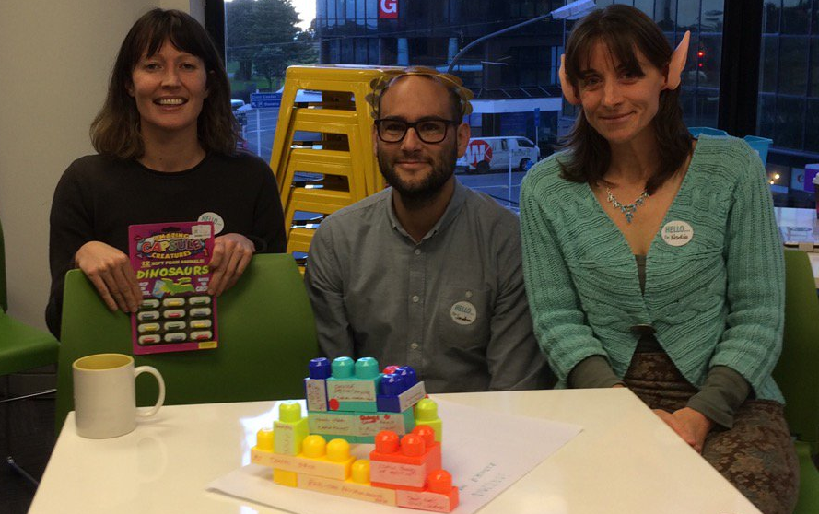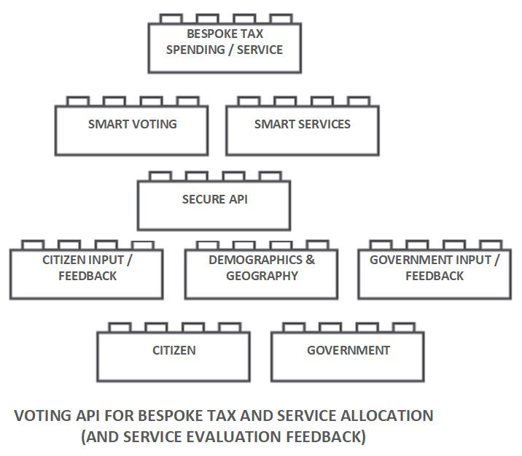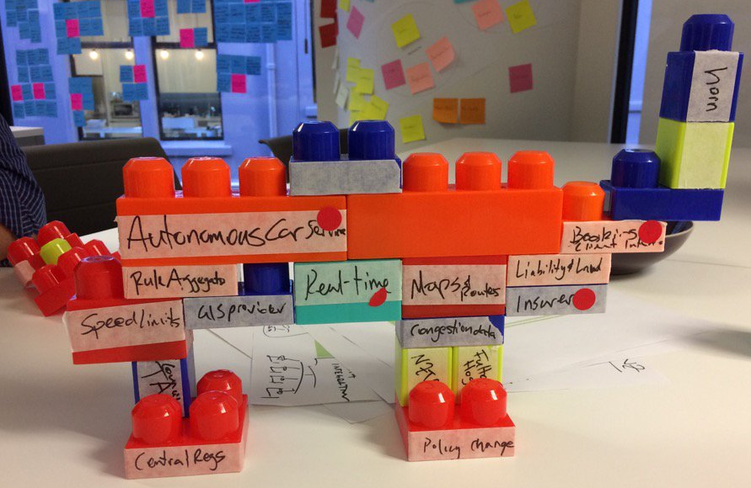
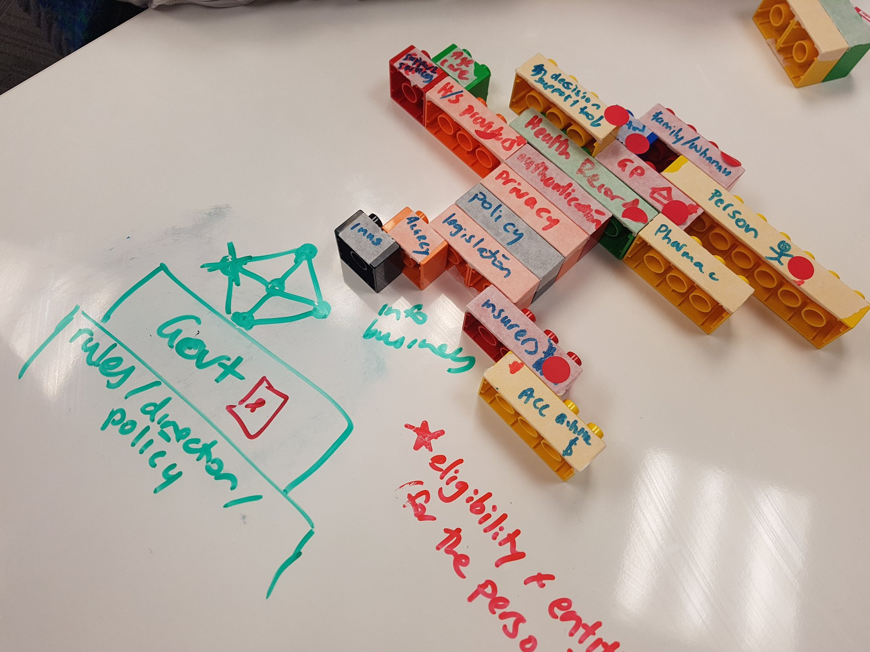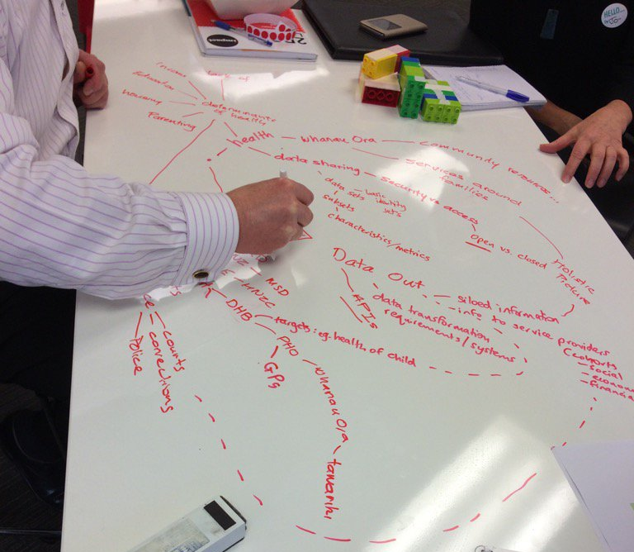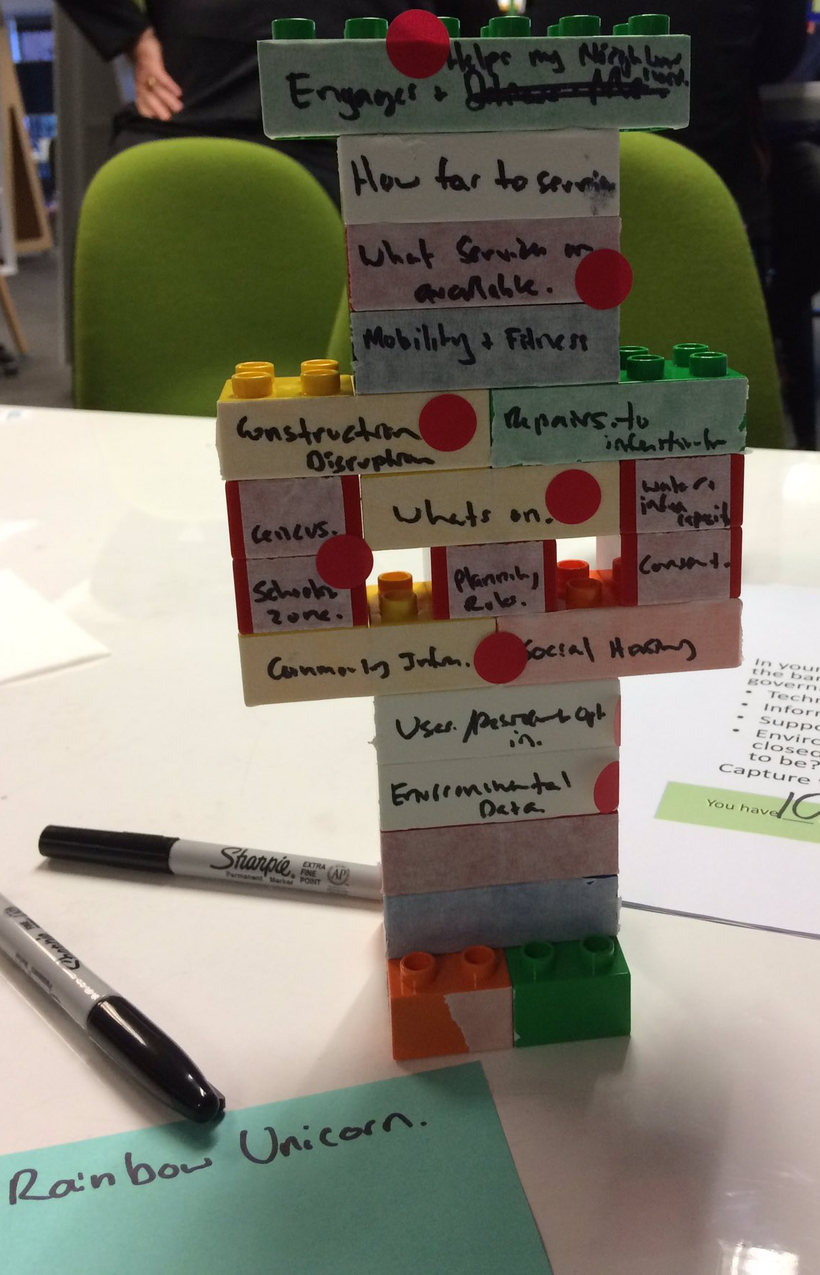
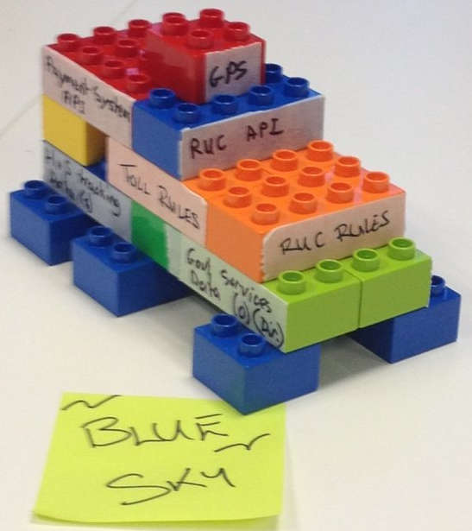

Assignment 3: user needs, barriers and benefits for potential intermediaries
We asked teams to spend a little time
- Technology:
  - Access to analytical models
  - A common / central government data model. Various departments would have their own models, but it should have the ability to be hooked back into a global government model to enable linking across various sectors and between government agencies.
  - Real time access to quality data (inc spatial)(4), business rules (2) and transactions
  - Pilot/testing support for experimentation.
  - Consistent, comparable and aggregated regional/central data sources (2)
  - Current and accurate data/end points
  - Machine readable rules and regulations across government (consolidated)
  - Logging/history of change for web services
  - The ability to interpret machine services (documentation, reference implementations, conditions of reuse/access) (2)
  - Standardised tagging
  - An agreed structure of need across govt, private, community which is understood by end user
  - Discrete, sophisticated service delivery
  - Standards (data+privacy+license+coding+data definitions+access) (2)
  - Discoverability of a) components upon which one could build with sources, and b) apps and reuse cases (2)
  - APIs!
  - Privacy and security for users, consent/control frameworks
  - One login across government
- Methods
  - User centred design for the reusable components (developer empathy)
  - Delivery is king

- Broader system:
  - Single source of truth for records but from multiple sources who capture the data
  - Interoperable systems
- Policy and support:
  - Clarity of what humans do in the system
  - Access to domain expertise
  - Active, accountable and timely decision making in government
  - Collaboration, engagement and buy-in, sharing and a willing openness (3)
  - Customer service - timely responsiveness around support for services and common clearn guidance (2)
  - Implementation drivers
  - Government needs to let go, be less controlling (2)
  - Funding (2)
  - People need to be able to define their own needs
  - Cross government commitment and visibility
  - Consistency across different agencies
  - Respect as a "citizen/taxpayer/resident", not a "customer" (customer is disempowering & mischaracterises relationship). As an open source developer I can inspect & contribute to platforms I interact with. Digital transformation implies similar expectations re citizens being able to interact with govt data & processes, not merely "consume".

Barriers:
- Advance requirements for companies to build on government components
- Perception of privacy risk
- Regulations are unclear right now
- Fear of non-compliance
- Jurisdictions and fear of loss of control
- Patch protection
- People expect tech (people, skills, systems) will not meet their needs
- Translation and bridging (of domains, disciplines, systems)
- Silos in government, lack of multi-org collaboration (2)
- Communication - recognising a need for what it actually is
- Culture - public and private sectors
- Funding and resources
- Closed data
- Non-connected data
- Lack of knowledge and where to get data/components
- No way to correlate ID across all gov, private and ngo systems
- API consistency, following best practices, and running UX for 3rd party devs (not just users/citizens). I consume many APIs from around the world and have discovered that that means a LOT of time learning the 'nuances' of each and then altering my code EVERY time they feel like changing their API.
- Practice consistency: e.g. water quality info is slowly being harmonised in some respects, but every regional council publishes data different (via API, PDF, Flash map widget etc.); this increases cost of obtaining a national picture.

Benefits of gov as a platform:
- Many dependencies could be privately supplied
- Opportunity for government to re-engage with digital generations of the population. Value can't be measured anymore by the time spent in meetings debating about what's good for citizens. Citizens want near real-time response to issues. Show me what you're doing about our issues and don't show me how you talked about it.
- Product benefits:
  - Smart Roads: Financial benefits to fleet and 3PL on behalf of pay as you go, real time responsiveness, route optimisation, health and safety, road maintenance, congestion management, administrative efficiencies.
  - Health data sharing: accuracy, consolidated medical history, quicker/earier/less errors/more efficient, avoid duplication or content creep, cheaper, people/companies/orgs could specialise in what they do best rather than duplicating, right data/time/person, simplification, more targeted service delivery.

